Oracle Database Administration Services
Oracle Database Start & Shutdown



This document contains proprietary information of Wipro Infotech – MIT. No part of this publication may be reproduced, stored in a retrieval system or transmitted in any form or by any means, whether electronic, mechanical, photocopying, recording or otherwise, without the prior written permission of Wipro Infotech – MIT. The information contained herein is confidential to Wipro Infotech – MIT and <Customer Name> and shall not be distributed to any persons other than those involved in the assessment and delivery of services. Wipro Infotech – MIT reserves the right to revise and update this document as and when required. Wipro Infotech – MIT reserves the right to withdraw the document excluding customer specific information at the time of termination of services.

All product names referenced herein are trademarks of their respective companies.
Document Management Information
Document Title : Oracle Start & Shutdown
Document Status : Draft / Review / Approval / Final
Document Publication History
(All revisions made to this document must be listed in chronological order)
Version | Date | Author(s) | Remarks
1.0 | 01-11-2008 | Buvanesh Mohana Murugan | Initial Draft Document
 | 24-07-2014 | Vineet Walia | Review and update
 | 12-07-2016 | Hemanti Thackeray | Review and update
Document Review and Approval History
(All revisions must be approved. Review and Approval can be done by an internal source or by the customer)
Version | Date | Reviewer & Approver | Remarks | Signature
1.0 | 20-11-08 | Premchand Ryali | Review
1.0 |  |  | Approval
Document Distribution List
Sl. No. | Name and Company | Purpose
1
2

TABLE OF CONTENT
1. Purpose 1
2. Scope 1
3. Database Startup Shutdown Flow Process 1
4. Steps To Start/Shutdown Database 2
4.1 Connect To The Server 2
4.2 Check for backup \ job is running 4
4.3 Check For Db Level Transaction Is Executing 4
4.3.1 Execute the topas command 4
4.3.2 Check the PID for the process 5
4.3.3 Obtain the corresponding SID And Hash Value for the PID Execute the below query and provide the PID, observed above as input 5
4.3.4 Determine the text of the query using hash value 7
4.4 Check for any user sessions logged in 7
4.5 Check for dependency of database with other database \ application 8
4.6 Database startup 8
4.7 Database Shutdown 8
5. Reference 8

Purpose
This document is prepared for Startup & shutdown of oracle database and listener of Oracle Database Administration Services at <Customer Name>.

Scope
This document is prepared for <Customer Name> Wipro sustenance team and provides the concepts of for Startup & shutdown of oracle database and listener at Linux at <Customer Name>.

Database Startup Shutdown Flow Process
The below sheet contains the flow for Database Startup Shutdown Flow Process:
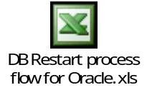
Note: The above flow is a draft. It is required to be modified on the customer discussion.

Steps To Start/Shutdown Database

Connect To The Server
Step 1: Double click on putty.exe



Step 2: Type the IP address of the server and select telnet. Then press ok.

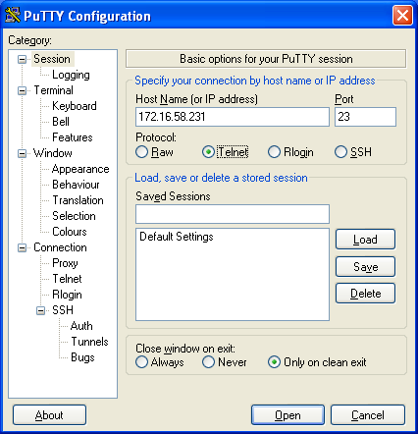

Step 3: It will ask for username and password. Give username and password.

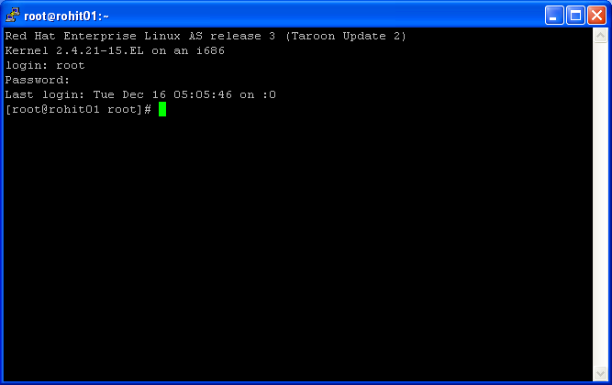

Check for backup \ job is running
Refer the start time; end time and log file for checking the status of job execution.

Check For Db Level Transaction Is Executing

Execute the topas command
Execute the topas command to obtain the CPU idleness. Execute the Topas command for AIX and top in rest of platforms viz. solaris, linux, etc.
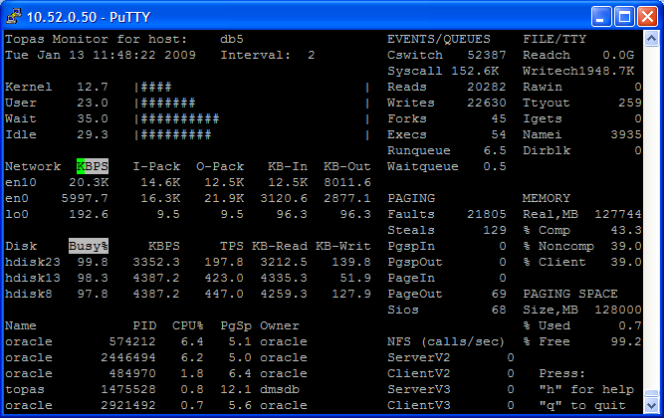

Here the CPU idleness is 29.3. This value is observed to be less than the optimal value which is 10%.

Check the PID for the process
Now check for the PID of the process with high CPU consumption

Obtain the corresponding SID And Hash Value for the PID Execute the below query and provide the PID, observed above as input
select S1.sid ,s1.serial#,s1.status,s1.SQL_HASH_VALUE,s2.sql_text from v$process p,v$session s1,v$sqlarea s2
where p.addr = s1.paddr and s1.SQL_HASH_VALUE = s2.HASH_VALUE
and p.spid=&spid;

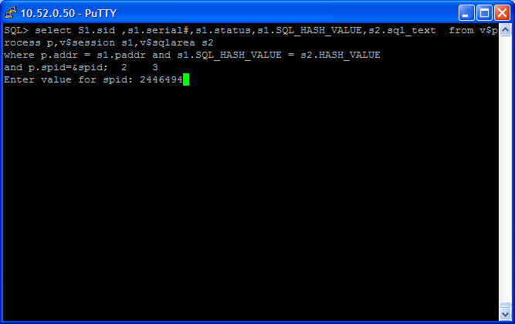

The output of the query as follows

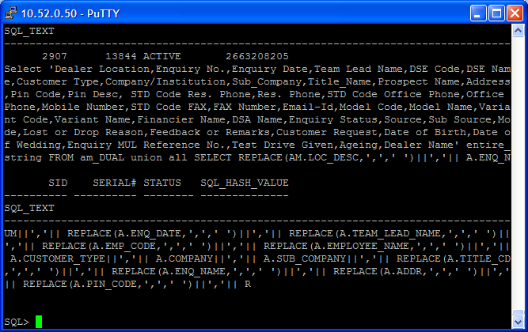

Determine the text of the query using hash value

SQL> select sql_text from stats$sqltext where hash_value in ('&hash') order by hash_value, piece;
Enter value for hash: 2301379024
old 1: select sql_text from stats$sqltext where hash_value in ('&hash') order by hash_value, piece
new 1: select sql_text from stats$sqltext where hash_value in ('2301379024') order by hash_value, piece

SQL_TEXT
----------------------------------------------------------------
SELECT BIN_LOC FROM PM_STOCK_BIN_LOC WHERE PARENT_GROUP = :B6 AN
D DEALER_MAP_CD = :B5 AND LOC_CD = :B4 AND STORES_CD = :B3 AND P
ART_NUM = :B2 AND COMP_FA = NVL (:B1 , COMP_FA)

Check for any user sessions logged in
Execute the below query to check the users logged in.
SQL> select user#,username from v$session;

USER# USERNAME
---------- ------------------------------
0
0
0 SYS
0
0
0
0
0
0
0
0

USER# USERNAME
---------- ------------------------------
0
0
0

14 rows selected.

SQL>

Check for dependency of database with other database \ application
Refer the Application Database Dependency for same.

Database startup
LISTENER Startup
$lsnrctl
$lsnrctl>start LISTENER

Starting the database
$ sqlplus “/ as sysdba”
SQL>startup
Instance Started
Database Mounted
Database Open

Database Shutdown
Stopping the database

$ sqlplus “/ as sysdba”
SQL>shutdown immediate
Database Closed
Database Dismounted
ORACLE instance shut down

LISTENER Shut Down
$ lsnrctl
$ lsnrctl>stop LISTENER

Reference
- http://www.dba-oracle.com/concepts/db_startup_shutdown.htm

